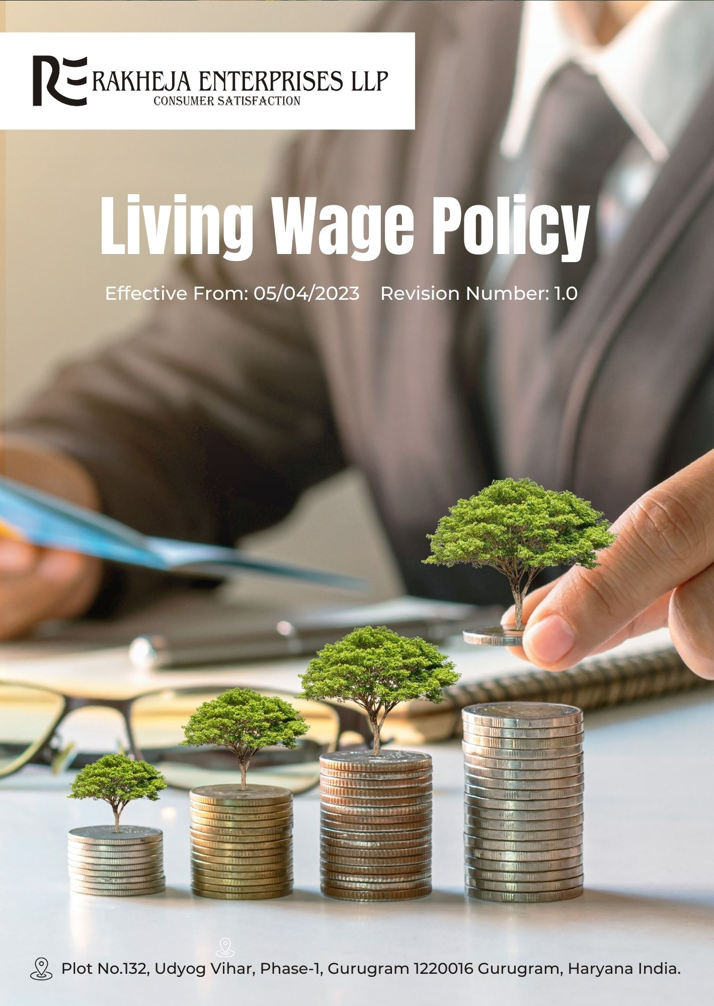
Table of Contents
1. Introduction 3
2. Planned objectives 3
3. Scope 3
4. Determining the Living Wage 3
5. Rakheja’s Living Wage key strategies and targets 4
6. Responsibility 4
7. Reporting 6
8. Continuous Improvement 7
9. Review Cycle 8
10. Acknowledgement by Employee 9

Introduction
Rakheja Enterprises LLP is committed to ensuring the financial well-being of our workforce. We recognize that fair compensation is essential for our employees' quality of life and our company's long-term success. This Living Wage Policy reflects our dedication to ethical business practices and employee welfare, in line with Indian labor regulations and global best practices.

Planned objectives
- Establish a fair wage structure that enables a decent living standard for all employees
- Align our compensation practices with the economic realities of our operational locations
- Promote financial stability within our workforce and surrounding communities
- Lead by example in our industry regarding equitable pay practices.

Scope
This Policy applies to all employees (at all levels), all stakeholders, partners, contractors, customers, suppliers, and any other individual or entity working on behalf of Rakheja Enterprises LLP. It also applies to all our manufacturing facilities.

Determining the Living Wage
Our living wage is calculated through:
- Biannual cost-of-living surveys in our operational areas
- Consultation with local economic experts
- Analysis of regional economic indicators
- Consideration of industry benchmarks
- Regular dialogue with employee representatives

Rakheja’s Living Wage key strategies and targets
- Equitable Benefits: We are committed to enhancing employee benefits to ensure they are comparable across all roles and departments, aiming for a 12% increase in benefits equity by FY 2025-26 compared to the FY 2022-23 baseline.
- Living Wage Initiative: We will implement a "Living Wage Initiative" to guarantee that all employees earn a living wage that is 8% higher than the local cost of living by FY 2025-26, improving from the FY 2022-23 baseline.
- Bonus Distribution Equity: Our goal is to ensure that bonus distributions are more equitable by reducing disparities between top earners and average employees by 20% by FY 2025-26, using FY 2022-23 as the reference point.
- Minimum Wage Compliance: We are focused on achieving full compliance with minimum wage standards across all locations, targeting a 100% compliance rate by FY 2025-26, up from our current baseline as of FY 2022-23.

Responsibility
- Human Resources Manager
- Policy Communication: Ensure all employees are informed about the Living Wage Policy and its implications through regular updates and training sessions.
- Benefits Review: Regularly review and adjust employee benefits to align with the equity targets set in the policy.
- Living Wage Initiative Oversight: Monitor the implementation of the Living Wage Initiative and ensure employees' wages meet the specified targets.
- Data Collection: Coordinate the biannual cost-of-living surveys and analysis to provide accurate information for wage adjustments.
- Compliance Monitoring: Track compliance with minimum wage standards and report any deviations to senior management.

- Financial Controller
- Budget Allocation: Allocate necessary resources and budget for implementing wage adjustments and employee benefits enhancements.
- Financial Analysis: Conduct financial analyses to ensure that the Living Wage Initiative and benefits equity targets are financially viable.
- Bonus Distribution Review: Oversee the distribution of bonuses to ensure alignment with equity targets and reduce disparities.
- Cost Impact Assessment: Assess the impact of living wage adjustments on overall company finances and provide recommendations for cost management.
- Compliance Reporting: Prepare and present financial reports on compliance with wage standards and policy targets to senior management.
- Operations Manager
- Local Surveys Coordination: Coordinate with local teams to facilitate biannual cost-of-living surveys and ensure accurate data collection.
- Regional Benchmarking: Analyze regional economic indicators and industry benchmarks to support wage determination processes.
- Facility Compliance: Ensure that all manufacturing facilities comply with the minimum wage standards and other policy requirements.
- Employee Feedback: Gather feedback from employees on wage and benefits satisfaction and report findings to the HR department.
- Implementation Support: Support the implementation of the Living Wage Initiative and benefits adjustments across operational areas.
- HR Manager
- Strategic Oversight: Provide strategic direction and ensure alignment of the Living Wage Policy with overall company goals and values.
- Performance Monitoring: Monitor the performance against the Living Wage targets and provide guidance for necessary adjustments.
- Stakeholder Engagement: Engage with external stakeholders and industry peers to demonstrate commitment to fair wage practices and gather insights.
- Annual Review: Conduct a biennial review of the policy's effectiveness and make strategic decisions based on performance and feedback.
- Employees
- Policy Awareness: Stay informed about the Living Wage Policy and understand how it affects your compensation and benefits.
- Feedback Participation: Provide feedback on wage and benefits through surveys and discussions to help improve the policy.
- Compliance Adherence: Ensure your personal understanding and compliance with any wage adjustments and benefits changes communicated by the company.
- Engagement in Surveys: Actively participate in biannual cost-of-living surveys and other data collection processes as requested.
- Reporting Issues: Report any discrepancies or concerns regarding wages and benefits to your manager or HR for prompt resolution.

Reporting
- Regular Wage Compliance Reports
We conduct annual evaluations of our wage practices, focusing on key metrics outlined in our Living Wage Policy. These reports provide a thorough assessment of compliance with wage standards, employee satisfaction, and progress towards fair wage objectives. They include:
- Compliance Evaluation: Review of adherence to living wage standards, including verification of wage payments against policy requirements and applicable legal standards.
- Employee Satisfaction: Measurement of employee feedback regarding wage fairness, adequacy, and overall satisfaction with compensation.
- Internal Audits
Internal audits are carried out to evaluate compliance with the Living Wage Policy and the effectiveness of our wage management systems. These audits:
- Assess Policy Adherence: Evaluate the extent to which wage practices align with established policies and standards, including accuracy of wage calculations and timely payments.
- Identify Improvement Areas: Highlight areas needing corrective actions and opportunities to enhance wage practices, ensuring all employees receive a living wage.
- Stakeholder Engagement
We actively engage with stakeholders, including employees, payroll administrators, and industry experts, to:
- Solicit Feedback: Gather input on wage practices, policy effectiveness, and areas for improvement from those directly affected by or knowledgeable about wage issues.
- Address Concerns: Respond to inquiries and concerns raised by stakeholders, ensuring their perspectives influence wage policy adjustments and implementations.
- Communicate Performance: Share updates on wage compliance, policy changes, and achievements related to ensuring living wages for all employees.

Continuous Improvement
To ensure our Living Wage Policy remains effective and responsive to evolving needs, we are committed to ongoing improvements. We regularly review and analyze performance data from our Wage Compliance Reports and Internal Audits to identify trends, challenges, and areas for enhancement. Insights gained from stakeholder feedback are instrumental in refining our practices and addressing any gaps. We also benchmark our policy against industry best practices and emerging standards to stay ahead of regulatory changes and expectations. Our approach includes setting measurable goals for wage equity and periodically updating our policy to incorporate innovative solutions and address any identified issues. By fostering a culture of continuous learning and adaptation, we aim to enhance our wage practices, ensure compliance with living wage standards, and uphold our commitment to fair and equitable compensation for all employees.

Review Cycle
Every two years, the HR Manager will conduct a comprehensive review of our Living Wage Policy to ensure its continued relevance and effectiveness. This review will involve a thorough assessment of compliance with wage standards, an evaluation of policy implementation, and an analysis of any emerging issues or trends affecting wage practices. The HR Manager will review performance data from Wage Compliance Reports, insights from Internal Audits, and feedback from stakeholder engagements. This process will also include benchmarking our policy against industry standards and legal requirements. Based on these findings, the HR Manager will recommend necessary updates or improvements to the policy. Any changes will be communicated to all stakeholders, ensuring transparency and alignment with our commitment to fair and equitable compensation.
Prepared By (Name) | HR Manager
Date of Preparation | 27/03/2023
Prepared by (Signature)
Approved By | General Manager
Date of Approval | 31/03/2023
Signature of Approver
Implementation Date | 05/04/2023
Next Review Date | 01/04/2025

Acknowledgement by Employee

I acknowledge that I have received, read, and understood the Living Wage Policy of Rakheja Enterprises LLP. I am aware that this policy outlines the company’s commitment to fair compensation and equitable benefits, and I understand the criteria used to determine the living wage. I agree to comply with all related requirements and participate in necessary surveys and feedback processes. I understand that the policy applies to all employees and that I am responsible for staying informed about any changes. I am also aware that my feedback is vital for continuous improvement, and any concerns regarding wages or benefits should be reported to my manager or HR department. I understand the importance of this policy in promoting financial stability and equitable pay.
Employee Name
Acknowledgement Date
Signature

